

WOLF VALLEY
NEWS

February Edition
2022

Welcome to the new Wolf Valley News!

Looking forward to the Snowdrops and Bluebells! The sun is already well on its way back!

This news sheet is supported by your Parish Council for Germansweek and Eworthy and covers those areas and beyond.

All are welcome to be involved. Please send your copy to the editor, details here and on the back page.

We hope to include all events locally, some advertising and all upcoming events along with ideas, suggestions, jokes. Please send us all that helps and encourages the community. Regular contributors will be from the Vicar, the Parish Council and local clubs.

There have not been many contributors so I thought I would publish a poem written in 1947 by my Mum’s friend who was Ed for the local youth club. One or two harsh words in there !

For two magazines in succession
I’ve sat in the editorial chair,
And articles now for this number,
I have searched for in utter despair,
Oh where, Oh where is the talent,
That surely lies hidden in clubs,
Jean Darling could write about eating,
Joyce Stone could write about stumping up subs,
But still I get no written matter,
Excepting, of course, from Miss Sykes,
Who says in a fit of depression,
Oh, aren’t all our girls lazy tykes,
Yet still I search round for some talent,
Determined to overcome strife,
The answer I get from the club-ites
Is, an article? Not on your life,
Alas, they were rude and resentful,
(I expected the rudeness of course),
At last, with regret, I decided,
My last hope would be to use force,
So, armed with my sword and my crowbar,
I tackled the girls one by one,
They now seem more keen to write something,
Hurray, The Club Mag had begun!
From now on my job was made easy,
I knew there were scripts on the way,
I just had to nag the girls at night-time,
And phone them all up day by day,
So now its completed, yes finished,
At last I’ve a moment to spare,
From all the hustle and bustle,
To sleep…in the editor’s chair!

From Ed with a ‘Grin’

Looking for additional articles for an issue or two.

Anyone?

Copy deadline is the 25th. day of the month for inclusion in the next month’s issue.

Paper copies to be found in Germansweek Telephone Box, Outside the Dairy in Germansweek, Eworthy Telephone Box (formerly the Scone Box). Online at www.germansweekpc.co.uk or contact: wolfeditor@icloud.com

Germansweek Parish Church:

Message from the Reverend:

Working on my own with no one but animals for company often allowed my mind to wander off into strange thoughts. What would it be like to be a cow or a horse? What do they think about if indeed they think at all? Where do thoughts come from anyway? Can animals believe in God?
Sometimes it felt like stepping through the looking glass until I watched an episode of the Simpsons in which Bart asked “if a robot had a human brain would it go to heaven?” which made me feel a bit normal again, in as far as Bart Simpson can be described as normal.
Back when I was milking cows robots and Artificial Intelligence were things confined to Star Trek, now robotic milking systems are a reality. Robotic engineering (I struggle with the term Artificial Intelligence or AI because on a dairy farm the 'AI man' had a completely differently role!) is advancing at an incredible rate and while it will have some incredible benefits it also poses some difficult questions.
A Japanese IT firm invented a thief catching robot. After running successful lab trials they decided to test it. After deploying it in Tokyo the robot caught 25 thieves in 24 hours.
The news broke out.
Much Impressed, the Americans ordered the robot for themselves. After deploying it in NYC the robot caught 30 thieves under 8 hours.
The UK, also impressed ordered the robot. Under 3 hours after its deployment in London the robot caught nearly 100 thieves.
Devon and Cornwall Police, thinking it might help with their under staffing situation, decided to give it a try.
After being deployed in Camborne for under 30 minutes the robot was stolen.
There are already computers that are capable of learning and make decisions that haven't been programmed into it, does that constitute thinking or free will? Will the robots of the future be self-aware, will they be able to feel pain or have imagination and dreams? Will they be able to fall in love or feel guilt? When do we call something alive? If we call it alive will it have rights? Will switching it off be murder?
Answers to these sorts of questions will have implications on our world view and will shape our concept of who we are. After all if robots are nothing more than electronic programming how will they be different to humans who are nothing more than DNA programming. Being a religious person I believe we are created in the image of God with a soul and free will. Without that idea I think I would struggle with two big questions in life: where do I come from? which is about identity and, where am I going? which is what gives us goals and meaning. The other great question being: Why did the robot cross the road? Answer: because it was programmed by the chicken.

Germansweek Parish Church Services, Notices and Events:

6th Holy Communion 11.15am Germansweek
13th No Service
20th Holy Communion 9.30am Bratton Clovelly
27th Evening Prayer 5.00pm Bratton Clovelly

News from Quizmass, the Christmas quiz

Hi all,

Well done for those that entered the Quizmass trail this year. It was great to see lots of people had been out and about this Christmas getting some fresh air and joining in. There were several people who had 100% correct answers so we put those entries into a drawer to pick the winner of the Christmas hamper. My impartial two year old Jaxon had the big honour of picking the lucky winner this year!
Congratulations went to Kate Bence who received the hamper on Christmas Eve ready for some tasty treats on the big day!
I hope everyone had a lovely Christmas and again well done for all those that entered this year.

Cllr Carlie Walker

Roadford Rowing Club

Happy New Rowing Year! Along with a New Year comes new faces and boats to the club and most welcome they are too! Our first full Club Day was Sunday 16th Jan and once again the weather was kind to us! Not that the weather is key to our activities but it’s just great being out at Roadford when conditions are better.

We have had some boats delivered from Exeter University Rowing Club (well priced and too good an opportunity to miss) and although they need a bit of tlc, we hope to use them very soon.
Some new faces have come along to recent Club Days to see what we are about and hopefully come along to future Taster Sessions (Spring) and/or join the club.

For info, the age ranges of Rowing Members is currently 14 - 60+. so age is no barrier in rowing. Come along for a chat - it would be good to see you.

Ian
07837 190678

News from the Parish Council

A quiet month without a meeting but despite that, we have kept a watching brief on the various responsibilities we have taken on board. Cllr Steve has been keeping a watching eye on our approach to BT regarding our request to get Eworthy on super fast broadband as soon as possible! This is proving a real waiting game as the Parish is in a queue for final costings and timings. It’s hard being patient and with the Covid situation this has become even more drawn out. Hopefully this will be resolved soon and then that area of the Parish can go forward with speed.
The good news is that shortly we might be able to have face to face meetings as legally this is the only way we can vote on matters . Zoom is no longer a legal method of decision making since May 2021 . The Clerk has been given powers by the Council to collate our views by email and send them onwards to the appropriate authorities but has yet to use this method. Hopefully meetings may occur from March, look for information on our Parish notice boards or Nextdoor for news. We generally hold a meeting once a month on the third Wednesday, at 7:30 in the Village Hall.
Finally you know you can keep up to date with Parish matters on our website and read about planning, meetings and events so you won’t miss out on anything. Thank you to the editor for publishing local walks to keep us fit and busy. They were sent to the Council but it seems only fair to publish them in our magazine so all can share. Meanwhile take care, keep warm and look out for others. Jacky

How about this local walk? Great route and loads to see on a clear day!

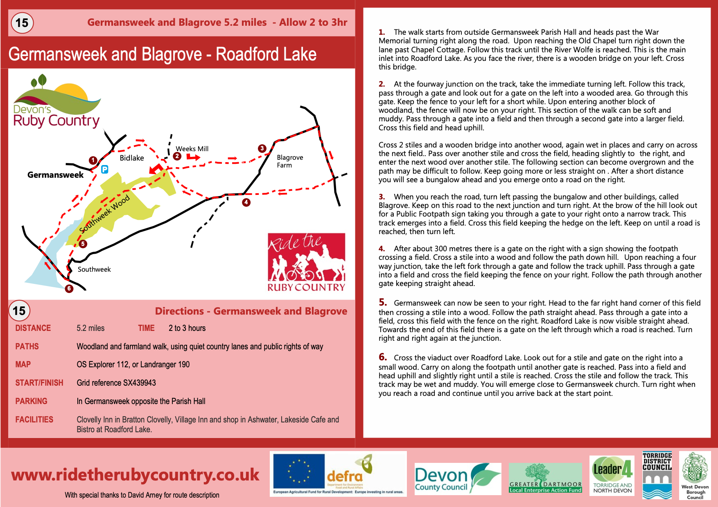

Upcoming/regular events or meetings;

Ivyhouse Garden Club (Broadwood). Please check www.nextdoor.co.uk for the next session . All welcome.

Sing along round 2 hold sessions every month in Germansweek Church.
Germansweek Cribbage Social. Check www.nextdoor.co.uk for updates and meetings.
Much more local information and events can be found on www.nextdoor.co.uk Please take some time to join up and keep up!

Contact Information:

Adrian Brook Parish Vicar 01837 861580

Jackie Theobald Parish Council Chair 01837 871446

Rachel Ward Parish Clerk Crane Cottage, Germansweek, EX21 5BA
germansweekpc@gmail.com

Germansweek Village Hall bookings; contact Eli Collins 01837 871317

Editor: wolfeditor@icloud.com

Please send your copies for inclusion. The deadline is 25th. of every month
Online copies to be found at www.germansweekpc.co.uk under ‘news’ tab

